INTRODUCTION TO ATTACHMENT-BASED PRACTICE WITH ADULTS, CHILDREN AND FAMILIES:

Tools for using attachment theory in your practice

### Presented by Clark Baim and Lydia Guthrie

### With Dr Ezra Loh and Dr Satbinder Kaur Bhogal

**Thursday 23rd October 2014**

**Venue: Oakhill Centre, Oakhill Close (off Meadow Road)**

**Harborne, Birmingham B17 8BB**

**Registration 9.15 am to start at 10 am and finish at 4:30 pm.**

**Fee: £36 (inclusive of VAT & buffet lunch)**

This one day workshop is for professionals from a range of disciplines who work with adults, children and families where insecure attachment and / or unresolved trauma and loss may be a significant factor affecting family members’ safety, health and well-being. The workshop is for professionals working within the NHS and is also relevant for practitioners working in CAMHS and within children’s services, as well as other mental health services.

**What the workshop offers**

* Understanding the key elements of contemporary attachment theory.
* Understanding the developmental pathways which lead to the different attachment / self-protective strategies.
* A chance for multi-disciplinary teams to develop a common language for discussing attachment, family dynamics and related issues.
* Identifying how different attachment strategies are expressed in verbal and non-verbal communication.
* A five-stage protocol for assessment, therapy and motivational working (the ‘LEARN’ model) that can be used to promote improved mental coherence and more integrated personal narratives.
* A plenary discussion with Dr. Ezra Loh and Dr Satbinder Kaur Bhogal, focusing on ‘next steps’ and learning to apply in practice.

The course will be a mixture of presentation and participatory work, with audio and video clips and small group practice time (However, no one will be asked to role play in front of the whole group or be ‘put on the spot!’). The presenters have extensive clinical, managerial and facilitation experience which encompasses child protection, risk management and work with adults whose behaviour is harmful to children.

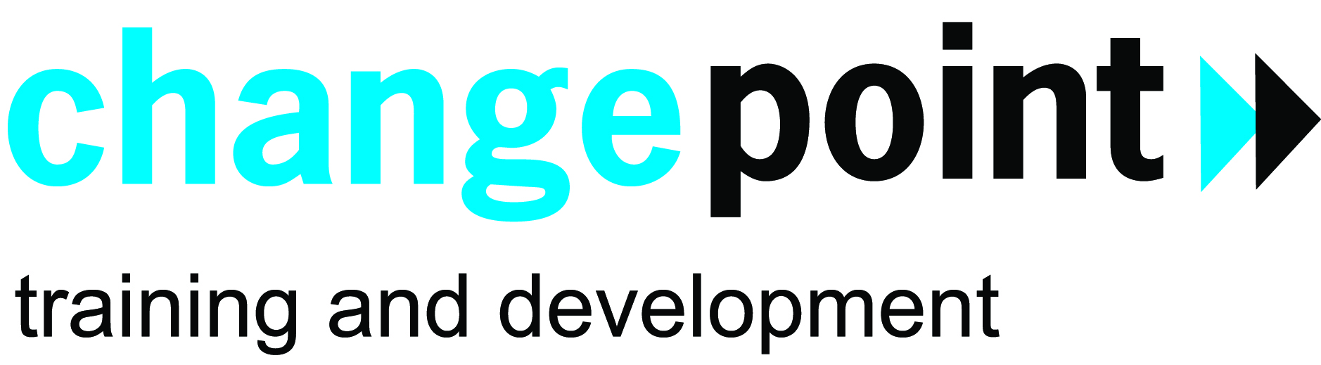

**Presenters:**

**Clark Baim,** M.Ed., UKCP, BPA, is a Senior Trainer in Psychodrama Psychotherapy and Co-Director of the Birmingham Institute for Psychodrama. In the 1990s, Clark worked as a group psychotherapist for five years at HM Prison Grendon, near Aylesbury, Bucks., and was from 2000-2012 the Co-Lead National Trainer for Sexual Offending Treatment Programmes run by the Probation Service. He has studied extensively in the Dynamic-Maturational Model (DMM) of Attachment with Dr. Patricia Crittenden, and co-developed the five stage therapeutic interviewing model based on the DMM with Tony Morrison. He is the co-author, with Tony Morrison, of ‘Attachment-based Practice with Adults,’ published 2011 by Pavilion. He and Lydia Guthrie are Co-Directors of Change Point Learning and Development, based in Birmingham.

**Lydia Guthrie,** MA Hons, MSc, Dip SW has a long track record of work in the criminal justice and voluntary sectors, including working with adults with disabilities and socially excluded young people. She qualified as a social worker in 1998, and worked for the Probation Service between 1998 and 2009. She has held a wide variety of roles, including Treatment Manager of the Thames Valley Sexual Offending Groupwork Programme and Senior Probation Officer, supervising a busy urban team of Offender Managers in Oxford. This work focused on the risk assessment and management of high risk offenders, and on the delivery of programmes, predominantly with sexual offenders, domestic abusers and their partners. She is a highly experienced trainer and facilitator and was from 2009-2012 the Co-Lead National Trainer for the Probation Service’s Sexual Offending Groupwork Programmes.

**Dr Ezra Loh,** MD, MMed (Psych), DMedSc (Psych), MRCPsych is dual accredited with specialist registrations in General Psychiatry (1999) and Child & Adolescent Psychiatry (2003). His doctorate research was on the assessments of mother-infant relationship difficulties in a clinically referred community sample of postnatally depressed mothers and their infants (2005). He has worked as a Consultant Psychiatrist in a community NHS CAMHS team in Birmingham since 2003 and has a special interest in complex developmental & unresolved psychological trauma in children & adolescents. He had offered neurodevelopmental & psychiatric consultations to Looked After Children’s CAMHS (now renamed TESS) teams and co-facilitated Group therapeutic work for mothers with psychiatric illnesses at the regional Mother & Baby Psychiatric Service at QEHB (2010-2011). After attending Dr. Patricia Crittenden’s foundational Attachment & Psychopathology Seminars (2010) he further trained in the use of the CARE-Index for mother-infant relationship assessment (0-15 months) (2010) and the Meaning of the Child (MotC) Parents Interview (2011-2013), all of which are based on the Dynamic-Maturational Model (DMM) of Attachment.

**Dr Satbinder Kaur Bhogal**, BSc Hons (Psy), D.Clin.Psych is a Clinical Psychologist who has extensive experience working in community, residential and secure and open hospital settings with children, young people and adults presenting with complex mental health difficulties. She has special interests in working with young people who are ‘Looked After’, attachment theory and trauma. She has provided mental health input, clinical supervision, consultation and training to a range of organisations in both the independent and statutory sectors working with young people who are ‘looked after.’ These include residential child care providers, social services departments and fostering and adoption agencies. She currently works in the NHS and independently with people with mental health difficulties. Underpinning all her work is the application of attachment theory in understanding the clinical presentations of clients with complex mental health problems.

***Feedback from previous workshops***

*‘On reflection, I couldn’t think of a more mindful and generous workshop, which appeared to increase every practitioner’s capacity for reflexivity. … What can I say – truly awe inspiring!’*

*‘The workshop was excellent – it all made such good sense. … More importantly, I am sure the knowledge will stick in my repertoire, unlike so many workshops where the knowledge evaporates. I am hooked.’*

**Timetable**

9:15 Arrival, registration, coffee

10:00 Welcome and context setting from Dr. Ezra Loh and Dr. Satbinder Kaur Bhogal

* 1. Introduction to the key elements of contemporary attachment theory. (Clark Baim & Lydia Guthrie)

10:45 The developmental experiences that lead to the different attachment / self-protective strategies.

11:30 Coffee

11:40 Identifying how different attachment strategies are expressed in verbal and non-verbal communication.

12:50 Lunch

1:35 A five-stage protocol for assessment, therapy and motivational working (the ‘LEARN’ model) that can be used to promote improved mental coherence and more integrated personal narratives.

2:50 Looking at some examples from practice, using video, audio and written transcripts.

4:00 A plenary discussion with Ezra Loh and Satbinder Bhogal, focusing on ‘next steps’ and learning to apply in practice.

4:30 Finish

INTRODUCTION TO ATTACHMENT-BASED PRACTICE

Please complete a booking form for each delegate

|  |
| --- |
| **YOUR DETAILS** |
| FIRST NAME (Please print clearly on this form) |
| SURNAME |
| Name of organisation |
| Delegate’s professional role in organisation: |
| WORK ADDRESS |
|  |
| WORK POSTCODE |
| WORK TEL EMAIL: |

❒ £36 fee enclosed. Please make cheques payable to Change Point Ltd.

❒ Invoice my work address ⎯ Please indicate to whom the invoice should go to below:

|  |
| --- |
| Name and Title |
| Work Address |
|  |
| please complete an application form for each individual. full payment must be made prior to the course. no refunds for cancellation less than one week prior to the event. |

Any dietary requirements?

Yes: _____________________________ No

i)For further enquiries or for expression of interest, please contact:

**Dr Ezra Loh** ([ccloh@doctors.org.uk](mailto:ccloh@doctors.org.uk))

**Dr Satbinder Kaur Bhogal** (drskbhogal@live.co.uk)

ii) Please send completed forms & cheques (made payable please to ‘Change Point Ltd.’) to:



**Clark Baim**

**Change Point Ltd.**

**35 Copthall Road**

**Handsworth**

**Birmingham**

**B21 8JP**

**Closing date: 13th October 2014**